Design Principles - Inversion of Control (IoC) and Dependency Injection (DI)
# Source: AI Source: Provided by: [Data Path: Persons Table -> ID Column: 1, Name_En Column: Motasem Essam] -> From: [ChatGPT] on [1/23/2026]
Inversion of Control (IoC) is the principle where high-level modules delegate the flow of control to lower-level modules or frameworks, rather than controlling everything themselves.
👉 Think of it like hiring a team of specialists — you define the goals, and they handle the details.

🔑 Key Points
# Source: AI Source: Provided by: [Data Path: Persons Table -> ID Column: 1, Name_En Column: Motasem Essam] -> From: [ChatGPT] on [1/23/2026]
• High-level components don’t instantiate or manage low-level modules directly
• Control flow is inverted: lower-level components are “called” when needed
• Supports decoupling, modularity, and testability
• Commonly implemented via Dependency Injection, Events, or Callbacks

❌ Bad Example
# Source: AI Source: Provided by: [Data Path: Persons Table -> ID Column: 1, Name_En Column: Motasem Essam] -> From: [ChatGPT] on [1/23/2026]
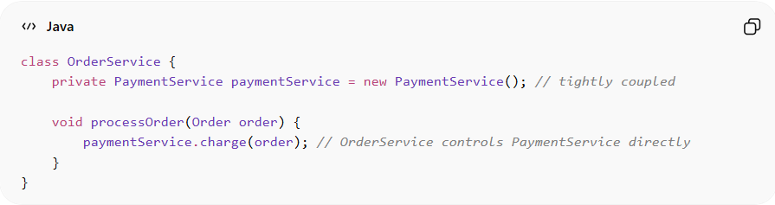
class OrderService {
private PaymentService paymentService = new PaymentService(); // tightly coupled

void processOrder(Order order) {
paymentService.charge(order); // OrderService controls PaymentService directly
}
}
Problems:
• OrderService controls the creation and usage of PaymentService
• Tightly coupled → hard to test or replace PaymentService
• Violates the IoC principle
• Hard to extend for different payment methods

✅ Good Example
# Source: AI Source: Provided by: [Data Path: Persons Table -> ID Column: 1, Name_En Column: Motasem Essam] -> From: [ChatGPT] on [1/23/2026]
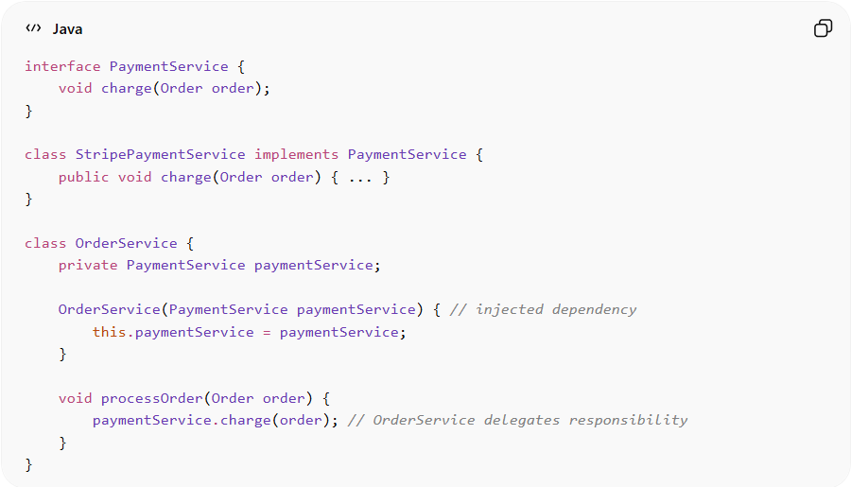
interface PaymentService {
void charge(Order order);
}

class StripePaymentService implements PaymentService {
public void charge(Order order) { ... }
}

class OrderService {
private PaymentService paymentService;

OrderService(PaymentService paymentService) { // injected dependency
this.paymentService = paymentService;
}

void processOrder(Order order) {
paymentService.charge(order); // OrderService delegates responsibility
}
}
Benefits:
• High-level module no longer controls low-level dependencies
• Easier to swap, test, or extend PaymentService
• Supports flexible, modular, and maintainable architecture
• Works naturally with frameworks and Dependency Injection

⚡ When to Apply
# Source: AI Source: Provided by: [Data Path: Persons Table -> ID Column: 1, Name_En Column: Motasem Essam] -> From: [ChatGPT] on [1/23/2026]
• In enterprise applications with multiple modules
• When building testable, flexible, and loosely coupled systems
• Works best with Dependency Injection frameworks (Spring, Guice, etc.)
• Combine with Hollywood Principle and SOLID principles for clean architecture

Dependency Injection (DI)
# Source: AI Source: Provided by: [Data Path: Persons Table -> ID Column: 1, Name_En Column: Motasem Essam] -> From: [ChatGPT] on [1/23/2026]
Dependency Injection (DI) is a design principle in software engineering where an object receives its dependencies from the outside instead of creating them itself.
It’s closely tied to writing loosely coupled, testable, and maintainable code.

🧠 Core Idea
# Source: AI Source: Provided by: [Data Path: Persons Table -> ID Column: 1, Name_En Column: Motasem Essam] -> From: [ChatGPT] on [1/23/2026]
Instead of this:
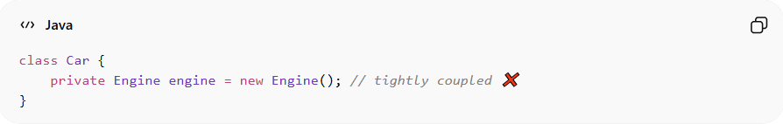
class Car {
private Engine engine = new Engine(); // tightly coupled ❌
}
You do this:
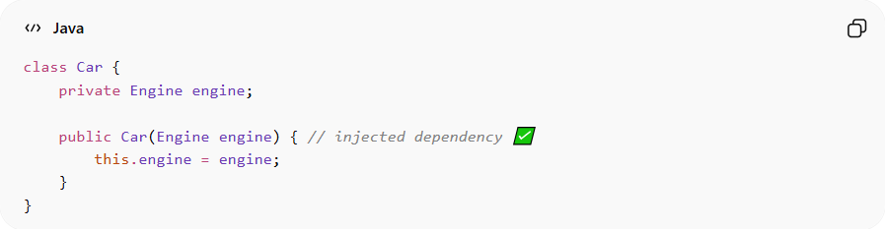
class Car {
private Engine engine;

public Car(Engine engine) { // injected dependency ✅
this.engine = engine;
}
}
👉 The Car doesn’t create the Engine anymore — it receives it.

🎯 Why Dependency Injection?
# Source: AI Source: Provided by: [Data Path: Persons Table -> ID Column: 1, Name_En Column: Motasem Essam] -> From: [ChatGPT] on [1/23/2026]
1. Loose Coupling
- Classes don’t depend on concrete implementations
- You can swap components easily
2. Easier Testing
- You can inject mock or fake objects
3. Better Maintainability
- Changes in one class don’t break others

🔧 Types of Dependency Injection (Java)

1. Constructor Injection (Most Common ✅)
# Source: AI Source: Provided by: [Data Path: Persons Table -> ID Column: 1, Name_En Column: Motasem Essam] -> From: [ChatGPT] on [1/23/2026]
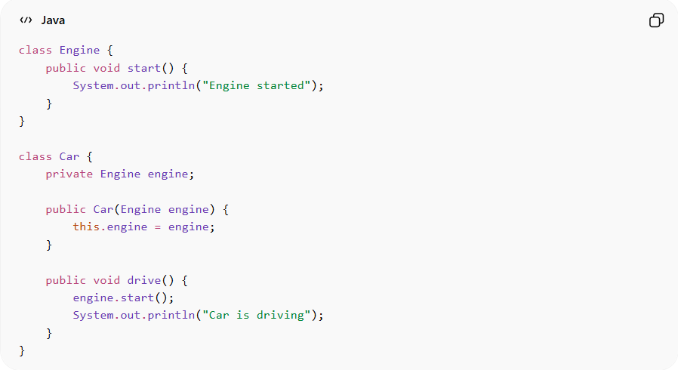
class Engine {
public void start() {
System.out.println("Engine started");
}
}

class Car {
private Engine engine;

public Car(Engine engine) {
this.engine = engine;
}

public void drive() {
engine.start();
System.out.println("Car is driving");
}
}
Usage:
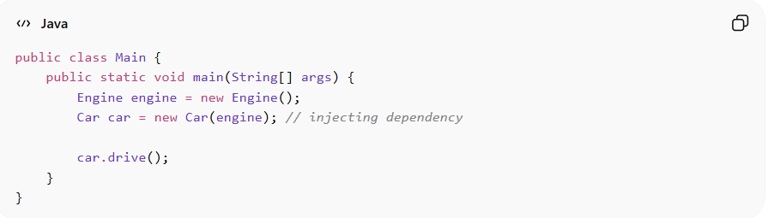
public class Main {
public static void main(String[] args) {
Engine engine = new Engine();
Car car = new Car(engine); // injecting dependency

car.drive();
}
}

2. Setter Injection
# Source: AI Source: Provided by: [Data Path: Persons Table -> ID Column: 1, Name_En Column: Motasem Essam] -> From: [ChatGPT] on [1/23/2026]
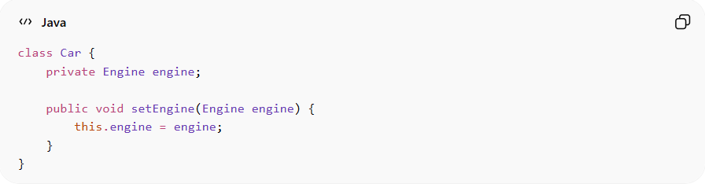
class Car {
private Engine engine;

public void setEngine(Engine engine) {
this.engine = engine;
}
}
Usage:
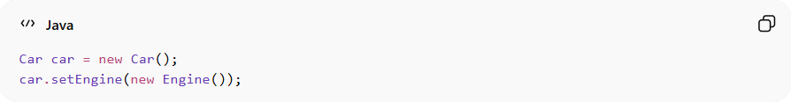
Car car = new Car();
car.setEngine(new Engine());

3. Field Injection (Not recommended in pure Java)
# Source: AI Source: Provided by: [Data Path: Persons Table -> ID Column: 1, Name_En Column: Motasem Essam] -> From: [ChatGPT] on [1/23/2026]
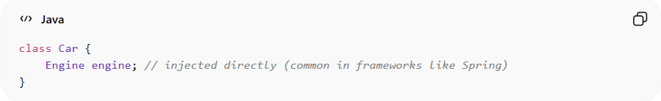
class Car {
Engine engine; // injected directly (common in frameworks like Spring)
}

🔁 Without DI vs With DI

❌ Without DI (Tight Coupling)
# Source: AI Source: Provided by: [Data Path: Persons Table -> ID Column: 1, Name_En Column: Motasem Essam] -> From: [ChatGPT] on [1/23/2026]
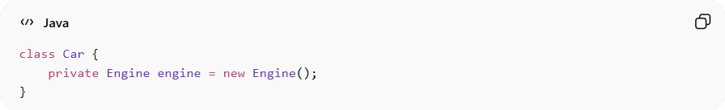
class Car {
private Engine engine = new Engine();
}
- Hard to replace Engine
- Hard to test

✅ With DI (Loose Coupling)
# Source: AI Source: Provided by: [Data Path: Persons Table -> ID Column: 1, Name_En Column: Motasem Essam] -> From: [ChatGPT] on [1/23/2026]
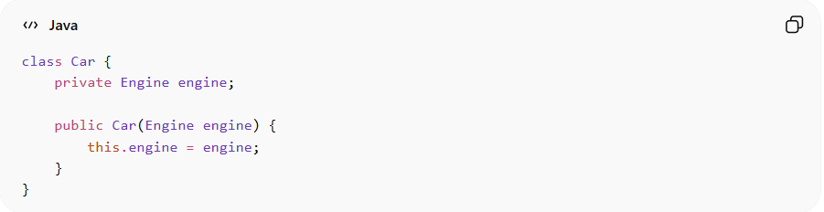
class Car {
private Engine engine;

public Car(Engine engine) {
this.engine = engine;
}
}
- Can pass ElectricEngine, DieselEngine, etc.
- Easy to mock in tests

🧩 Real-World Analogy
# Source: AI Source: Provided by: [Data Path: Persons Table -> ID Column: 1, Name_En Column: Motasem Essam] -> From: [ChatGPT] on [1/23/2026]
Think of a phone charger:
- ❌ Without DI: Phone builds its own charger
- ✅ With DI: You plug in any compatible charger

🧪 Testing Example (Mocking)
# Source: AI Source: Provided by: [Data Path: Persons Table -> ID Column: 1, Name_En Column: Motasem Essam] -> From: [ChatGPT] on [1/23/2026]
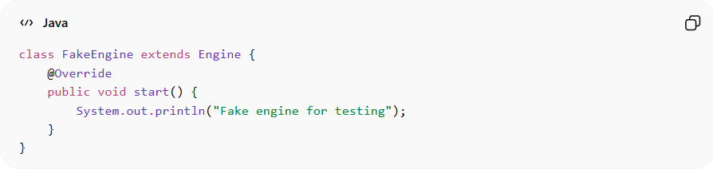
class FakeEngine extends Engine {
@Override
public void start() {
System.out.println("Fake engine for testing");
}
}
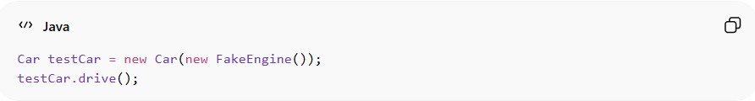
Car testCar = new Car(new FakeEngine());
testCar.drive();

🏗️ Related Design Principles
Dependency Injection supports:
- SOLID Principles
  - Especially D → Dependency Inversion Principle (DIP)
👉 High-level modules should not depend on low-level modules — both depend on abstractions.

relation between Dependency Injection (DI) and Inversion of Control (IoC)
# Source: AI Source: Provided by: [Data Path: Persons Table -> ID Column: 1, Name_En Column: Motasem Essam] -> From: [ChatGPT] on [1/23/2026]

🧠 Big Picture
- Inversion of Control (IoC) = a broad design principle
- Dependency Injection (DI) = a specific way to implement IoC
👉 So the relationship is:
DI is a type of IoC

🔄 What is Inversion of Control (IoC)?
# Source: AI Source: Provided by: [Data Path: Persons Table -> ID Column: 1, Name_En Column: Motasem Essam] -> From: [ChatGPT] on [1/23/2026]
IoC means:
You don’t control object creation and flow — something else does.
❌ Without IoC (you control everything)
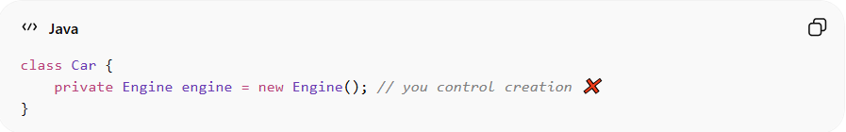
class Car {
private Engine engine = new Engine(); // you control creation ❌
}
👉 Car is responsible for creating its dependencies

✅ With IoC (control is inverted)
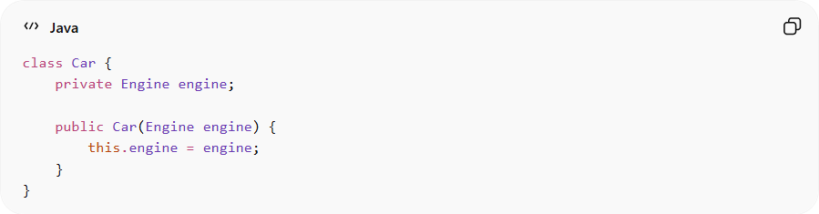
class Car {
private Engine engine;

public Car(Engine engine) {
this.engine = engine;
}
}
👉 Something else provides the Engine

💉 What is Dependency Injection (DI)?
# Source: AI Source: Provided by: [Data Path: Persons Table -> ID Column: 1, Name_En Column: Motasem Essam] -> From: [ChatGPT] on [1/23/2026]
DI is how IoC is achieved:
Dependencies are “injected” into a class from the outside
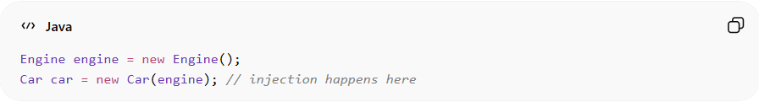
Engine engine = new Engine();
Car car = new Car(engine); // injection happens here

🔗 Relationship (Key Insight)
# Source: AI Source: Provided by: [Data Path: Persons Table -> ID Column: 1, Name_En Column: Motasem Essam] -> From: [ChatGPT] on [1/23/2026]
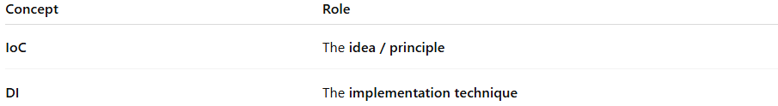
Concept | Role
IoC | The idea / principle
DI | The implementation technique
👉 Think of it like:
- IoC = “Don’t call us, we’ll call you”
- DI = “We’ll pass you what you need”

⚖️ DI vs IoC (Simple Comparison)
# Source: AI Source: Provided by: [Data Path: Persons Table -> ID Column: 1, Name_En Column: Motasem Essam] -> From: [ChatGPT] on [1/23/2026]
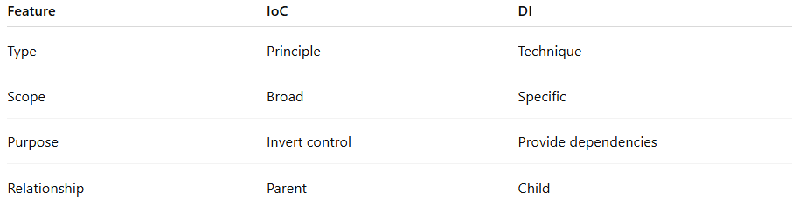
Feature | IoC | DI
Type | Principle | Technique
Scope | Broad | Specific
Purpose | Invert control | Provide dependencies
Relationship | Parent | Child

🧠 Analogy
# Source: AI Source: Provided by: [Data Path: Persons Table -> ID Column: 1, Name_En Column: Motasem Essam] -> From: [ChatGPT] on [1/23/2026]
🍽️ Restaurant
- Without IoC: You cook your own food
- With IoC: Restaurant cooks for you
Now:
- DI: Waiter brings food to your table

✅ Final Takeaway
# Source: AI Source: Provided by: [Data Path: Persons Table -> ID Column: 1, Name_En Column: Motasem Essam] -> From: [ChatGPT] on [1/23/2026]
- IoC is the concept
- DI is the most popular way to implement it
- Most modern frameworks (like Spring) use DI to achieve IoC

⚡ Bonus: With Spring Framework
# Source: AI Source: Provided by: [Data Path: Persons Table -> ID Column: 1, Name_En Column: Motasem Essam] -> From: [ChatGPT] on [1/23/2026]
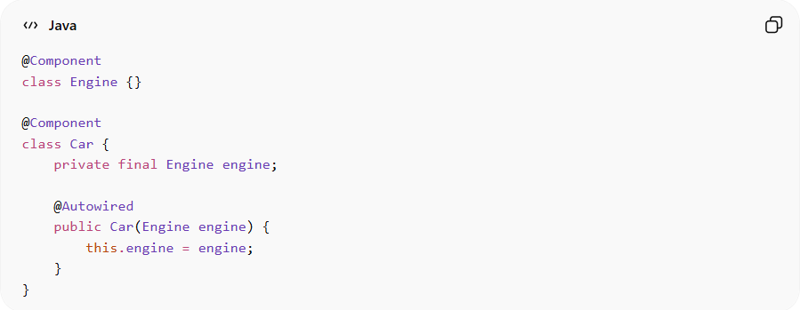
In frameworks like Spring Framework:
@Component
class Engine {}

@Component
class Car {
private final Engine engine;

@Autowired
public Car(Engine engine) {
this.engine = engine;
}
}
👉 Spring automatically injects dependencies for you.

✅ Summary
# Source: AI Source: Provided by: [Data Path: Persons Table -> ID Column: 1, Name_En Column: Motasem Essam] -> From: [ChatGPT] on [1/23/2026]
- Dependency Injection = provide dependencies from outside
- Improves:
  - Flexibility
  - Testability
  - Maintainability
- Best practice in modern Java development

🧩 Other Ways to Achieve IoC (besides DI)
# Source: AI Source: Provided by: [Data Path: Persons Table -> ID Column: 1, Name_En Column: Motasem Essam] -> From: [ChatGPT] on [1/23/2026]
DI is not the only way:

1. Service Locator Pattern
# Source: AI Source: Provided by: [Data Path: Persons Table -> ID Column: 1, Name_En Column: Motasem Essam] -> From: [ChatGPT] on [1/23/2026]
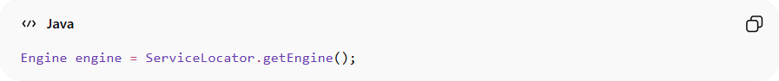
Engine engine = ServiceLocator.getEngine();
👉 The class pulls dependencies instead of receiving them

The Service Locator Pattern is a way to manage dependencies where a class asks (looks up) for what it needs instead of having it passed in.

🧠 Core Idea
# Source: AI Source: Provided by: [Data Path: Persons Table -> ID Column: 1, Name_En Column: Motasem Essam] -> From: [ChatGPT] on [1/23/2026]
A central registry (the Service Locator) holds services, and classes retrieve dependencies from it when needed.

🔍 Simple Java Example

Step 1: Create a Service
# Source: AI Source: Provided by: [Data Path: Persons Table -> ID Column: 1, Name_En Column: Motasem Essam] -> From: [ChatGPT] on [1/23/2026]
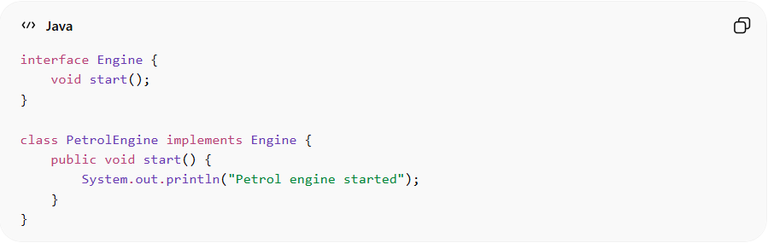
interface Engine {
void start();
}

class PetrolEngine implements Engine {
public void start() {
System.out.println("Petrol engine started");
}
}

Step 2: Create the Service Locator
# Source: AI Source: Provided by: [Data Path: Persons Table -> ID Column: 1, Name_En Column: Motasem Essam] -> From: [ChatGPT] on [1/23/2026]
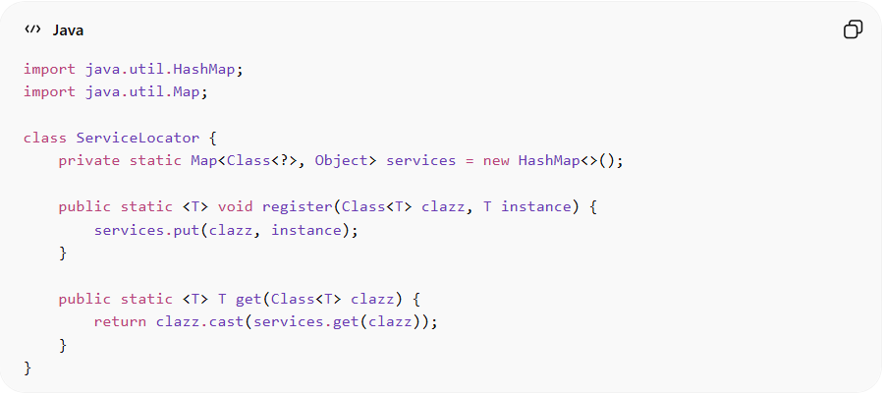
import java.util.HashMap;
import java.util.Map;

class ServiceLocator {
private static Map<Class<?>, Object> services = new HashMap<>();

public static <T> void register(Class<T> clazz, T instance) {
services.put(clazz, instance);
}

public static <T> T get(Class<T> clazz) {
return clazz.cast(services.get(clazz));
}
}

Step 3: Use It
# Source: AI Source: Provided by: [Data Path: Persons Table -> ID Column: 1, Name_En Column: Motasem Essam] -> From: [ChatGPT] on [1/23/2026]
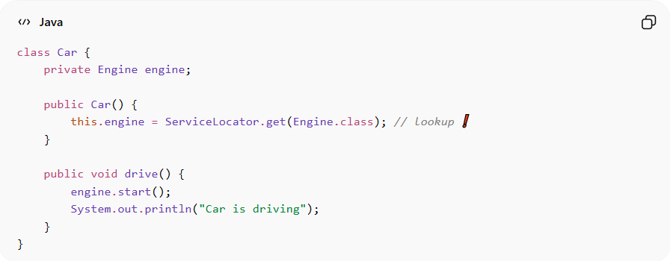
class Car {
private Engine engine;

public Car() {
this.engine = ServiceLocator.get(Engine.class); // lookup ❗
}

public void drive() {
engine.start();
System.out.println("Car is driving");
}
}

Step 4: Main
# Source: AI Source: Provided by: [Data Path: Persons Table -> ID Column: 1, Name_En Column: Motasem Essam] -> From: [ChatGPT] on [1/23/2026]
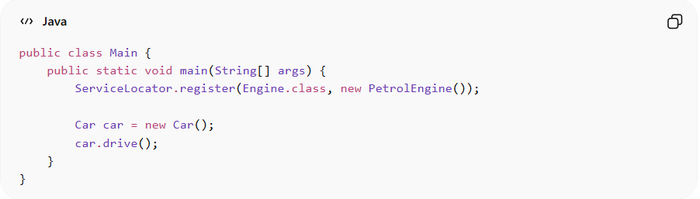
public class Main {
public static void main(String[] args) {
ServiceLocator.register(Engine.class, new PetrolEngine());

Car car = new Car();
car.drive();
}
}

⚖️ Service Locator vs Dependency Injection
# Source: AI Source: Provided by: [Data Path: Persons Table -> ID Column: 1, Name_En Column: Motasem Essam] -> From: [ChatGPT] on [1/23/2026]
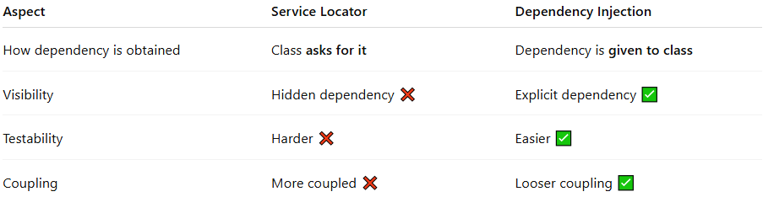
Aspect | Service Locator | Dependency Injection
How dependency is obtained | Class asks for it | Dependency is given to class
Visibility | Hidden dependency ❌ | Explicit dependency ✅
Testability | Harder ❌ | Easier ✅
Coupling | More coupled ❌ | Looser coupling ✅

❗ Why Service Locator is Controversial

🚫 1. Hidden Dependencies
# Source: AI Source: Provided by: [Data Path: Persons Table -> ID Column: 1, Name_En Column: Motasem Essam] -> From: [ChatGPT] on [1/23/2026]
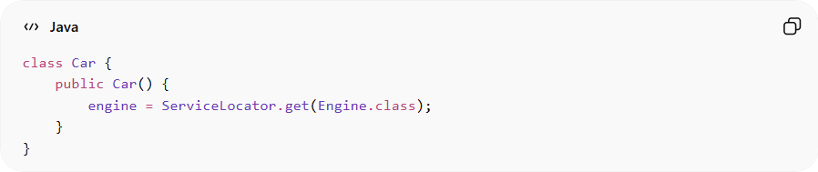
class Car {
public Car() {
engine = ServiceLocator.get(Engine.class);
}
}
👉 You can’t tell from the constructor what Car depends on.

🚫 2. Harder to Test
# Source: AI Source: Provided by: [Data Path: Persons Table -> ID Column: 1, Name_En Column: Motasem Essam] -> From: [ChatGPT] on [1/23/2026]
- You must configure the locator before tests
- Global state can cause bugs

🚫 3. Violates Transparency
# Source: AI Source: Provided by: [Data Path: Persons Table -> ID Column: 1, Name_En Column: Motasem Essam] -> From: [ChatGPT] on [1/23/2026]
- Dependencies are not obvious
- Makes code harder to understand

✅ When It Might Be Used
# Source: AI Source: Provided by: [Data Path: Persons Table -> ID Column: 1, Name_En Column: Motasem Essam] -> From: [ChatGPT] on [1/23/2026]
- Legacy systems
- Simple apps
- When DI frameworks aren’t available

🧠 Relationship to IoC
# Source: AI Source: Provided by: [Data Path: Persons Table -> ID Column: 1, Name_En Column: Motasem Essam] -> From: [ChatGPT] on [1/23/2026]
- It still follows Inversion of Control
- But uses a different approach than DI
👉 Both:
- Invert control
But:
- DI = dependencies are pushed in
- Service Locator = dependencies are pulled

🍽️ Analogy
# Source: AI Source: Provided by: [Data Path: Persons Table -> ID Column: 1, Name_En Column: Motasem Essam] -> From: [ChatGPT] on [1/23/2026]
- Dependency Injection → waiter brings food 🍽️
- Service Locator → you go to the counter and pick it up 🧍‍♂️

✅ Final Summary
# Source: AI Source: Provided by: [Data Path: Persons Table -> ID Column: 1, Name_En Column: Motasem Essam] -> From: [ChatGPT] on [1/23/2026]
- Service Locator = central registry for dependencies
- Classes fetch dependencies themselves
- It implements IoC, but:
  - ❌ Hides dependencies
  - ❌ Harder to test
- 👉 Generally less preferred than DI

2. Framework Control (Hollywood Principle)
# Source: AI Source: Provided by: [Data Path: Persons Table -> ID Column: 1, Name_En Column: Motasem Essam] -> From: [ChatGPT] on [1/23/2026]
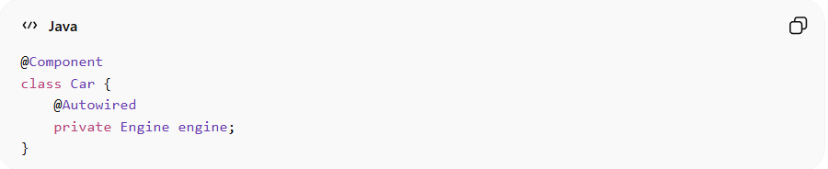
Frameworks like Spring Framework:
@Component
class Car {
@Autowired
private Engine engine;
}
👉 The framework:
- Creates objects
- Injects dependencies
- Controls lifecycle

The Hollywood Principle (often called Framework Control) is a core idea in modern frameworks:
“Don’t call us, we’ll call you.”

🎬 What Does That Mean?
# Source: AI Source: Provided by: [Data Path: Persons Table -> ID Column: 1, Name_En Column: Motasem Essam] -> From: [ChatGPT] on [1/23/2026]
Instead of your code controlling everything…
👉 The framework controls the flow and calls your code when needed

🔄 Without Framework Control
# Source: AI Source: Provided by: [Data Path: Persons Table -> ID Column: 1, Name_En Column: Motasem Essam] -> From: [ChatGPT] on [1/23/2026]
You control everything manually:
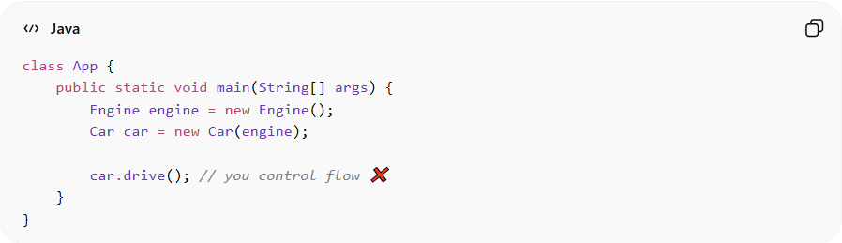
class App {
public static void main(String[] args) {
Engine engine = new Engine();
Car car = new Car(engine);

car.drive(); // you control flow ❌
}
}

🎯 With Framework Control (Hollywood Principle)
# Source: AI Source: Provided by: [Data Path: Persons Table -> ID Column: 1, Name_En Column: Motasem Essam] -> From: [ChatGPT] on [1/23/2026]
The framework takes over:
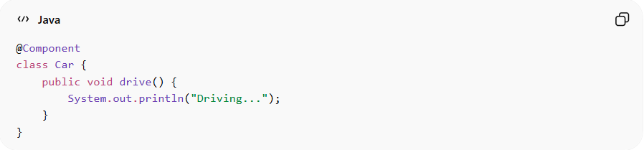
@Component
class Car {
public void drive() {
System.out.println("Driving...");
}
}
👉 In a framework like Spring Framework:
- You don’t call Car
- The framework creates it and calls it when needed

🧠 Key Idea
# Source: AI Source: Provided by: [Data Path: Persons Table -> ID Column: 1, Name_En Column: Motasem Essam] -> From: [ChatGPT] on [1/23/2026]
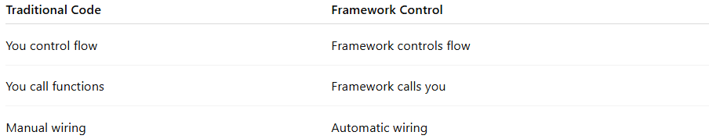
Traditional Code | Framework Control
You control flow | Framework controls flow
You call functions | Framework calls you
Manual wiring | Automatic wiring

🔗 Relation to IoC & DI
# Source: AI Source: Provided by: [Data Path: Persons Table -> ID Column: 1, Name_En Column: Motasem Essam] -> From: [ChatGPT] on [1/23/2026]
- Hollywood Principle is a form of
👉 Inversion of Control
- And it often works together with:
  - Dependency Injection (DI)
👉 Flow:
- Framework creates objects
- Injects dependencies
- Calls your methods when needed

🧩 Real Java Example (Spring Boot)
# Source: AI Source: Provided by: [Data Path: Persons Table -> ID Column: 1, Name_En Column: Motasem Essam] -> From: [ChatGPT] on [1/23/2026]
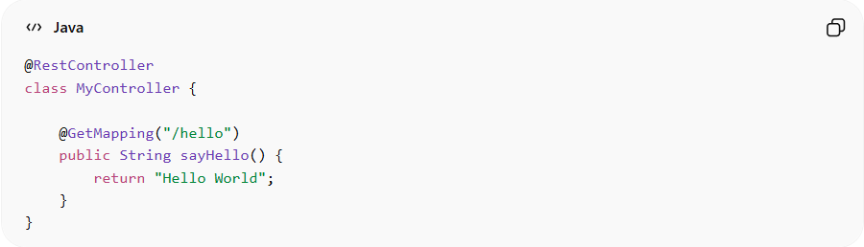
@RestController
class MyController {

@GetMapping("/hello")
public String sayHello() {
return "Hello World";
}
}
👉 What happens:
- You never call sayHello()
- Spring calls it when an HTTP request arrives

🍽️ Analogy
# Source: AI Source: Provided by: [Data Path: Persons Table -> ID Column: 1, Name_En Column: Motasem Essam] -> From: [ChatGPT] on [1/23/2026]
Restaurant 🍴
- ❌ Without Hollywood Principle:
  - You go to kitchen, cook food yourself
- ✅ With Hollywood Principle:
  - Chef decides when to cook
  - Waiter brings food when ready
👉 You just define what should happen, not when

⚙️ Where You See It
# Source: AI Source: Provided by: [Data Path: Persons Table -> ID Column: 1, Name_En Column: Motasem Essam] -> From: [ChatGPT] on [1/23/2026]
- Spring Framework
- Hibernate
- JavaFX
- Android SDK

⚖️ Benefits
# Source: AI Source: Provided by: [Data Path: Persons Table -> ID Column: 1, Name_En Column: Motasem Essam] -> From: [ChatGPT] on [1/23/2026]
✅ Cleaner Code
- Focus on business logic
✅ Less Boilerplate
- Framework handles lifecycle
✅ Better Structure
- Standardized flow

⚠️ Downsides
# Source: AI Source: Provided by: [Data Path: Persons Table -> ID Column: 1, Name_En Column: Motasem Essam] -> From: [ChatGPT] on [1/23/2026]
❌ Less Control
- Framework decides execution order
❌ Learning Curve
- You must understand framework lifecycle

✅ Final Summary
# Source: AI Source: Provided by: [Data Path: Persons Table -> ID Column: 1, Name_En Column: Motasem Essam] -> From: [ChatGPT] on [1/23/2026]
- Hollywood Principle = “Don’t call us, we’ll call you”
- It’s a form of IoC
- Framework:
  - Controls execution
  - Calls your code
- Widely used in modern Java frameworks

